CO–PO STUDENT ASSESSMENT REPORT | Student ID: 22-46715-1
INDIVIDUAL PROJECT ASSESSMENT | WEB TECHNOLOGIES
CO4 criteria, detailed components, and recorded student marks
Name | Mim Akter | Student ID | 22-46715-1 | Group | 10 | Section AA
Git Repo | https://github.com/utsho-9/CraveCart/tree/feature/Customer
CO4 ASSESSMENT
CO4: Coordinate with group members to develop multi-tier based web application
Technical Knowledge (0-3) |  |  |  | Collaborative Teamwork (0-3) |  | Communication/Promptness (0-3) |  | Total
JS validation | PHP Validation | Ajax/JSON | Marks  (0-3) | Git Contribution | Marks  (0-3) | VIVA | Marks  (0-3) | Total CO4 marks  (out of 9)
5 | 5 | 0 | 2.0 | 4 | 2.4 | 4 | 2.4 | 6.8
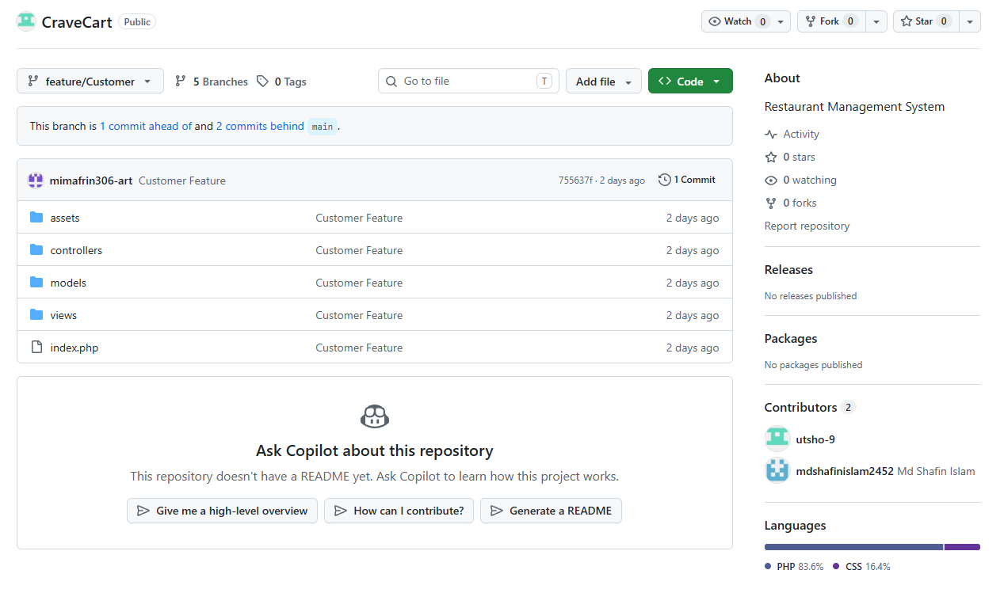
Repository Evidence

